Design Doc

Card Game

By Gabriel Sonkowsky

Mechanics

1. Card Game
   1. Creature/Monster/Minion etc.
      1. Hearthstone style: health, attack, effect, cost
   2. Spells
      1. only on your turn
   3. Keywords
      1. +x/+y: gives x stats
      2. Capital: mana
      3. Health
      4. Attack
   4. AI
      1. Plays based on simple heuristic (total health of followers and self - total health of opponent followers and self = heuristic)

Aesthetics

Creature/Minion etc. are employees in a company, have art that is royalty free stock images of mundane things like farmers, lawyers, office workers etc.

Winning is a hostile takeover.

Player is CEO of their company, tutorials/play guide can have lines like “attack the enemy CEO and reduce their Reputation to zero”

Controls

Click and drag cards from hand to the game board to play them.

Click and drag followers onto other followers or your opponent to attack.

Task Checklist

* Prototypes -Completed
  + Follower -Completed
  + Spell -Completed
* Hand Controller -Completed
  + Draw -Completed
    - Parse card type -Completed
    - Use prototype to create card -Completed
  + Rearrange -Completed
  + Mana -Completed
  + Deck -Completed
  + Face -Completed
* Card Dragging -Completed
  + To self -Completed
  + To board -Completed
* Gameboard
  + Holds followers -Completed
  + Rearrange -Completed
  + Followers can hit each other and face -Completed
* Enemy AI
  + Hand -Completed
  + Plays actions -Completed
  + Heuristic for “best” action -Completed
* Gameplay
  + Game Loop -Completed
  + Make many cards -Made some
    - Script these cards -Completed
  + Add progression/draft between games -TODO

Playtests

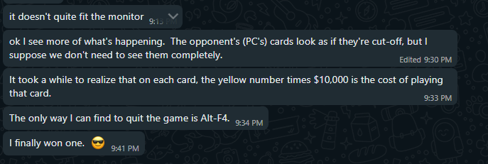

-From a Friend



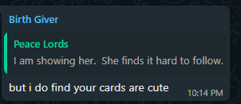

-From my Mother





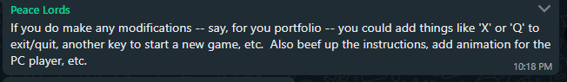

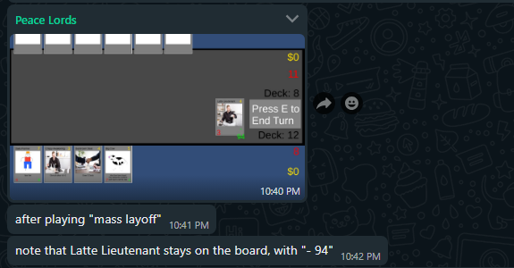

-From my Father

Takeaways

* Experienced bug with simultaneous removal.
* No clear tutorial (instructions on itch.io are too brief)
* Some aspect ratios do not work well
* Suffers from lack of menus/system controls for quit/restart etc. (lack of time for polish)